*“O’magnify the LORD with me, and let us exalt his name together”. (Psalm 34:3)*

BEULAH BAPTIST CHURCH

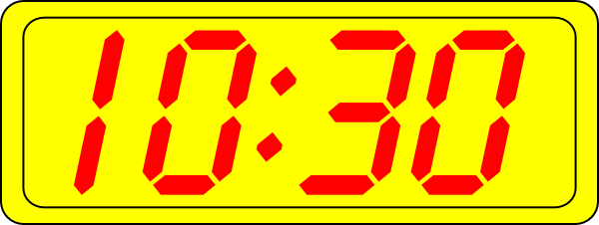

*JOIN US FOR SERVICE ON  &* 

[www.facebook.com/beulahbaptistchurchphiladelphia](http://www.facebook.com/beulahbaptistchurchphiladelphia)

*Praise & Worship then a Word from our Pastor*

**LIVE PRAYER with Pastor Henley at 11:50PM on our Church Phone Line at 978-990-5162, Access Code 828753#**

**Praying on our Knees into 2021! Bless New Year!**

*“O’magnify the LORD with me, and let us exalt his name together”. (Psalm 34:3)*

*Reverend William Henley, Pastor*