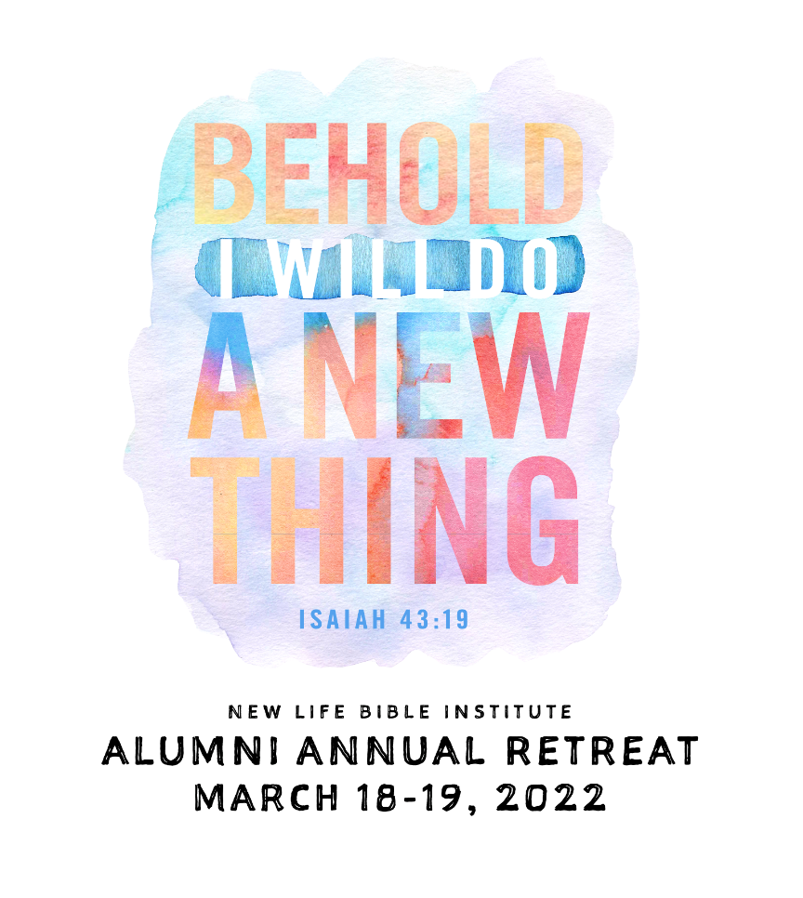

Theme: “Behold, I Will Do a New Thing”
Isaiah 43:19
Facilitator: Reverend Gregory Sales
Conference and Workshop will be provided by StreamYard and Zoom in the comfort of your own home!
COST: $40 PER PERSON
(WHICH INCLUDES ALL RETREAT CONFERENCE AND WORKSHOP MATERIALS, TEE- SHIRT AND ADMINISTRATIVE COST)
FINAL PAYMENT DUE FEBRUARY 18, 2022

PLEASE COMPLETE THE REGISTRATION FORM ON THE BACK SIDE

REGISTRATION FORM
PLEASE PRINT
Full Name:__________________________________________________
Mailing Address:_____________________________________________
City: __________________________ State: _________ZIP:___________
Phone #: ____________________________________________________
(Required) Email Address ________________________________
Tee Shirt size (circle one) Medium Large XLarge 2X 3X
Amount enclosed: $_________________________

***Make checks or money order payable to “NLBIAA”***
THEN, MAIL your check or money order to:
Cheryl A Johnson (Attn: NLBIAA Retreat)
PO Box 282
Bala Cynwyd PA 19004

Links and Agenda will be provided and ALL materials and T- shirts will be mailed out to you
For more information contact:
CHERYL A JOHNSON (215) 473-7043 OR
CHARMAINE JACKSON (610) 529-1657

[Please return this completed form with your payment]

