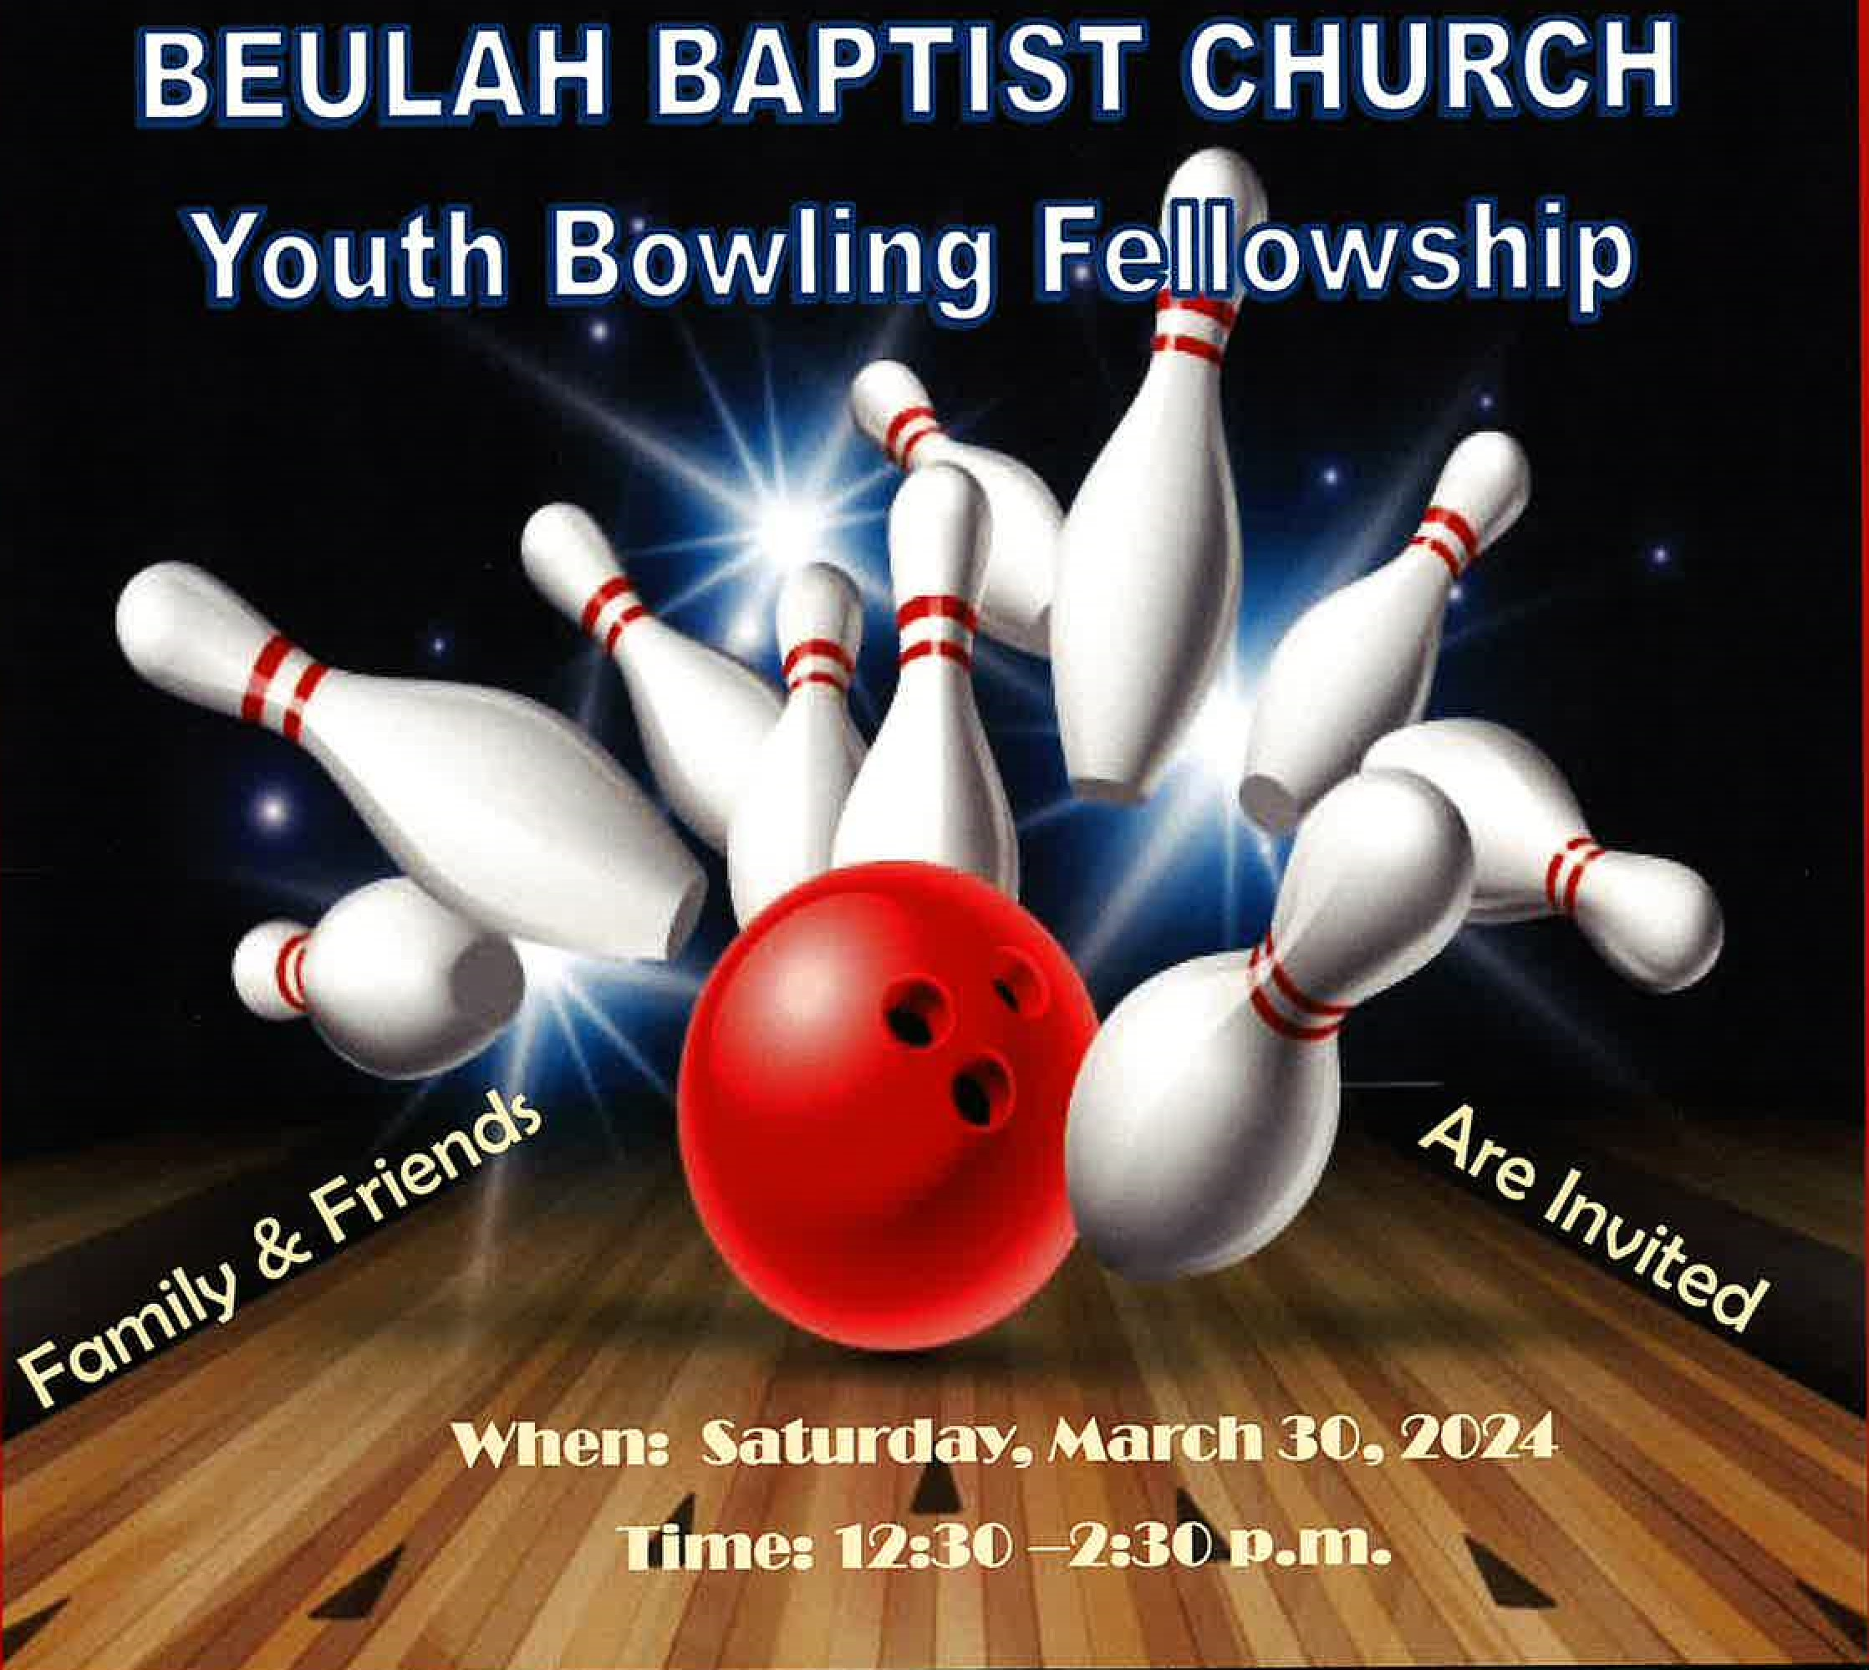

CHURCH

COSTS: $18.50 (INCLUDES SHOES)

WHERE: Wynnewood Lanes - 2228 Haverford Road, Ardmore, PA

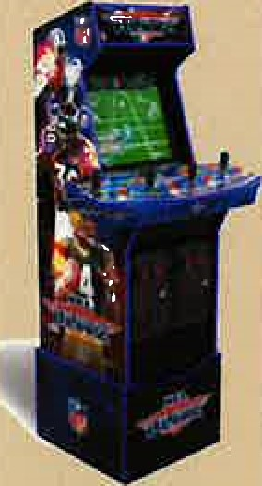Limited transportation for Beulah Youth. Everyone else, meet us there.

If interested, contact Darlene Richardson

(1 John 4:11 Beloved, ifGod so loved us, we ought also to love one another.)

Hosted by the Youth Ministry

Beulah Baptist Church, 5001-21 Spruce Street, Phila, PA 19139

Reverend William Henley, Pastor