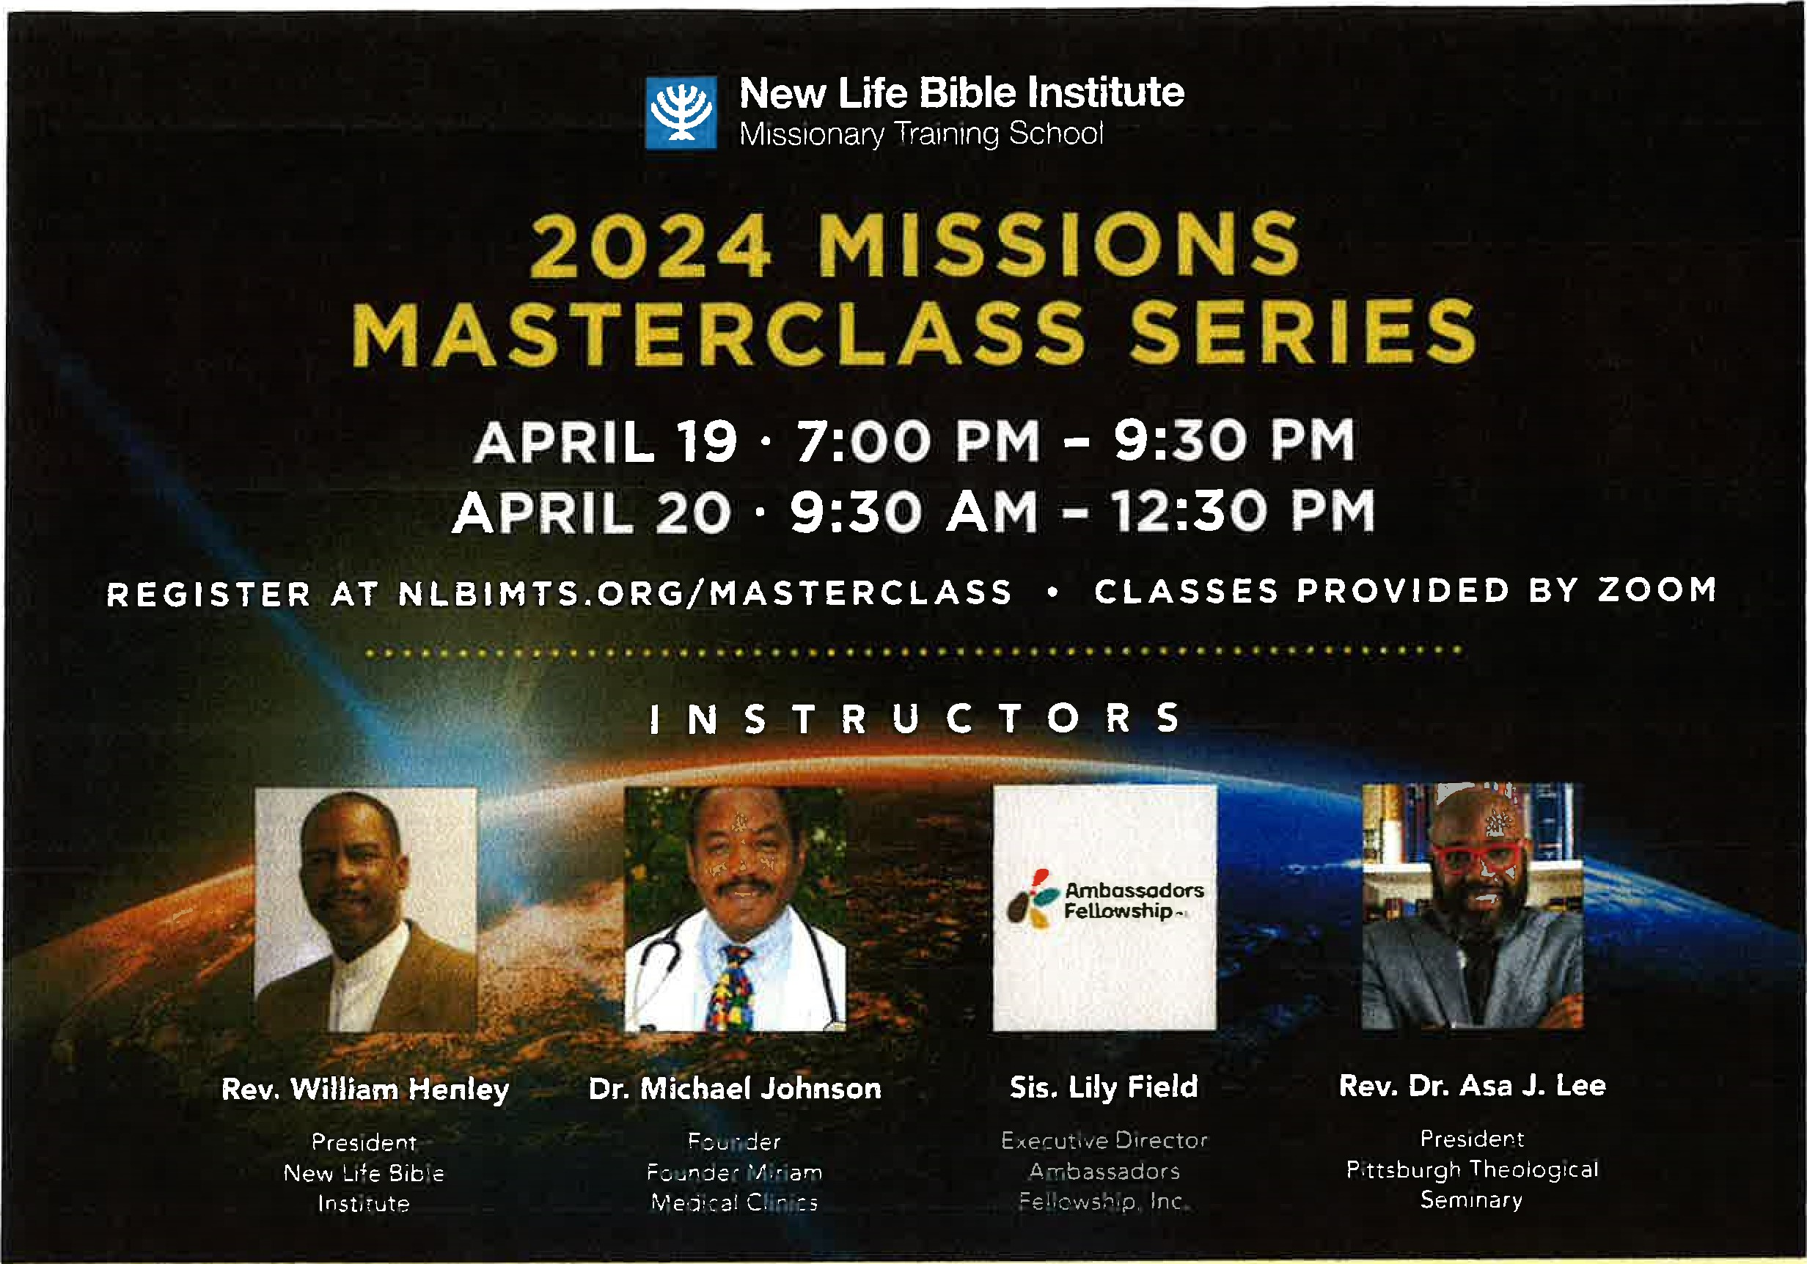
S C H E D U L E

APRIL 19 • 7:00 PM - 9:30 PM
Rev. William Henley, President, NLBIMTS
Topic: "Prayer and Evangelism"

APRIL 20 • 9:30 AM - 10:30 AM
Dr. Michel Johnson, Founder, Miriam Medical Clinics
Topic: "The Ugly Jesus — Despised and Rejected of men..."

APRIL 20 • 10:30 AM - 11:30 AM
Sis. Lily Field, Executive Director, Ambassadors Fellowship, Inc.
Topic: "Presenting the Gospel Cross-Culturally [Contextualization]"

APRIL 20 11:30 AM - 12:30 PM
Rev. Dr. Asa Lee, President, Pittsburgh Theological Seminary
Topic: "Church in Crisis'

REGISTER AT NLBIMTS.ORG/MASTERCLASS
For more information contact Canies Jenkins (cjenkins@nibimts.org)
Bro. John Ruffin, Dean • Rev. William Henley, President • Rev. Timothy E. Ruffin, Founder
New Life Bible Institute Missionary Training School • Beulah Baptist Church (Main Campus) • 5001-21 Spruce St., Phila., PA 19139

